**1.Association Mismatching:-**

In Object oriented Data model, we achieve the association between two clases by declaring One class type variable in another class definition.

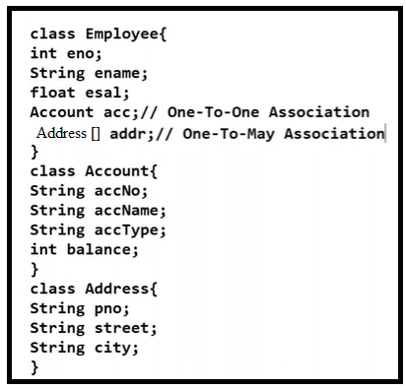

In Relation Data model, we achieve relation/association between two relations by definfing PK-FK relationship or by defining join columns.

Representing the association in Object-oriented data model and RelationData model is different.

To resolve this association mismatch, Hibernate provided four mechanisms.

a.one-to-one association Mapping.

b.one-to-many association Mapping.

c. many-to-one association Mapping.

d. many-to-many association Mapping.